Project Proposal: Outdoor Advertising Billboard Management System

Project Title
Outdoor Advertising Billboard Management & Rental Dashboard

APPROVED BY TA: Chenyan Zhu

SUBMITTED BY GROUP 19
1. Hiteshi Kawadia (002067922)
2. Preksha Praveen (002013697)
3. Manav Shah (002582617)
4. Jayashree Muniyappa (002535021)

Problem Statement
Outdoor advertising infrastructure—billboards, digital displays, transit panels—is operated by multiple entities across cities. A single advertising campaign often requires coordination among:
- Billboard Operators
- Advertising Agencies
- Brand Marketing Teams
- City Permit Departments
- Utility & Power Authorities
However, these groups currently communicate through scattered emails, manual spreadsheets, siloed systems, and phone calls. This lack of unified infrastructure results in:
- Double-booking or lost advertising opportunities
- Delays in maintenance, lighting, and power restorations
- Compliance failures due to late permit renewals
- Inefficiencies in campaign planning and execution
- Fragmented communication between enterprises
The Billboard Management System solves these problems by enabling cross-enterprise, multi-party coordination through a single communication and operations platform.
The whole becomes greater than the sum of its parts—campaigns run smoother, downtime decreases, and revenue increases across the network.

Project Objectives and Goals

Primary Objective
To design and implement a Swing-based ecosystem platform that enables seamless communication and workflow management between multiple enterprises involved in outdoor advertising.

Key Goals
- Build a multi-party communication ecosystem spanning 4 enterprises.
- Enable real-time collaboration using role-based work areas and work requests.
- Provide a centralized system for billboard availability, bookings, maintenance, permits, and power issues.
- Implement map-based visualization and reporting modules.
- Allow brands to join waitlists for high-demand billboards.
- Integrate with Faker to auto-generate data for demo and analytics.

Core Functionalities
- Role-based authentication with secure credentials
- Work request routing between enterprises
- Billboard catalog, details, and availability tracking
- Booking + waitlist + approval workflows
- Permit management with city authorities
- Power & lighting request management
- Maintenance assignments and completion tracking
- Reporting dashboards for KPIs
- CRUD operations for boards, campaigns, users, and work requests
- Pre-configured sample data using java-faker

User Roles and Use Cases

Ecosystem Structure
- 1 Ecosystem: GlobalOutOfHomeEcoSystem
- 1 Network: MetroAdNetwork (Boston)

Enterprises (Required for team of 4)
- Billboard Operator Enterprise – BillboardEnterprise
- Advertising Agency Enterprise – AdAgencyEnterprise
- City Services Enterprise – CityServicesEnterprise
- Utility & Power Enterprise – PowerUtilityEnterprise

Organizations (8 total, required for team of 4)
Billboard Operator Enterprise
- BillboardSalesOrganization
- BillboardOperationsOrganization
Advertising Agency Enterprise
3. AgencyClientServicesOrganization
4. AgencyCampaignPlanningOrganization
City Services Enterprise
5. CityPermitsOrganization
6. ComplianceInspectionOrganization
Utility & Power Enterprise
7. PowerGridMaintenanceOrganization
8. FieldEngineersOrganization

Roles
Billboard Operator Enterprise
- BillboardSalesManagerRole
- BillboardOpsManagerRole
Advertising Agency Enterprise
3. AgencyAccountManagerRole
4. CampaignPlannerRole
5. BrandMarketingManagerRole (client)
City Services Enterprise
6. CityPermitOfficerRole
7. CityComplianceInspectorRole
Utility & Power Enterprise
8. PowerGridCoordinatorRole
9. FieldMaintenanceEngineerRole
10. SafetyCheckOfficerRole

Use Cases (Work Requests)

1. Campaign Booking Request (Cross-Enterprise)
BrandMarketingManager → AgencyAccountManager → BillboardSalesManager
- Request to rent a board for specific dates
- System checks conflicts + waitlist

2. Board Selection Request (Cross-Enterprise)
CampaignPlanner → BillboardSalesManager
- Planner selects boards based on target audience
- Operator confirms availability and pricing

3. Permit Approval Request (Cross-Enterprise)
BillboardSalesManager → CityPermitOfficer
- Ensure legal compliance before campaign start

4. Compliance Inspection Request (Cross-Organization)
BillboardOpsManager → CityComplianceInspector
- Required for new installations and digital displays

5. Maintenance Request (Cross-Organization)
BillboardSalesOrganization → BillboardOperationsOrganization
- Fix lighting damage, torn flex, structural issues

6. Power Issue Request (Cross-Enterprise)
BillboardOpsManager → PowerGridCoordinator
- Power outage or lighted board malfunction

7. Field Engineer Assignment Request (Internal Utility Enterprise)
PowerGridCoordinator → FieldMaintenanceEngineer
- On-site power repair task assignment

System Architecture and Design Approach

Architectural Style:
- Layered MVC architecture with a distributed organizational data model
- Ecosystem → Network → Enterprise → Organization → UserAccount → WorkArea

Core Components
- EcoSystem: Holds everything
- Network: Represents a geographic region
- Enterprises & Organizations: Logical division of responsibilities
- Roles: Dictate permissions + WorkArea UI
- WorkRequest System: Communication backbone
- Directories: Manage boards, campaigns, users, requests
- UI Panels: Swing Work Areas for each role

Design Approach
- Build domain model first (UML)
- Define work requests and routing logic
- Implement CRUD forms with validation
- Integrate java-faker for preloading data
- Add reporting & analytics
- Add map-based billboard visualization (static image + markers)

UML Class Diagram

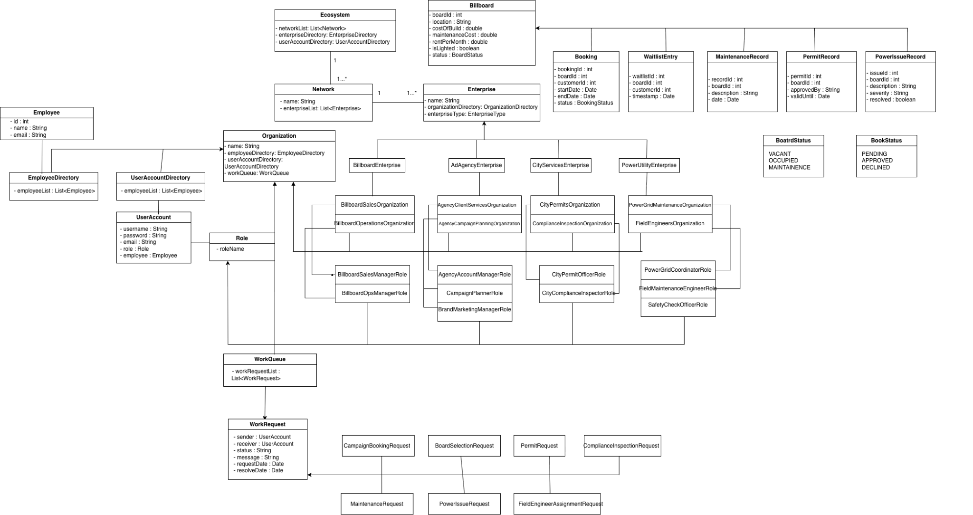

Data Input and Output

Inputs
- User login credentials
- Form data for boards, campaigns, permits, power issues
- Work request creation inputs
- Faker-generated sample data

Outputs
- Status dashboards
- Map view with board markers
- Reports:
  - Occupancy trends
  - Revenue
  - Maintenance statistics
  - Permit approvals timeline
  - Power outage logs

Implementation Plan and Timeline

Week 1
Day 1:
- Set up project structure
- EcoSystem + Network + Enterprise + Organization hierarchy
Day 2:
- UserAccount + authentication module
- Registration + Role-based work area switching
Day 3:
- Billboard model + CRUD
- Admin (BillboardSalesManager) board management panel
Day 4:
- Customer/Brand browsing (vacant boards table + search)
- Board detail pop-up
Day 5:
- Booking model + waitlist logic
- Conflict-handling + request routing

Week 2
Day 1:
- Admin booking approval interface
- Cross-enterprise work request flow
Day 2:
- Map View Panel (static city map + markers)
Day 3:
- Reporting module (charts/tables)
- System-level performance summaries
Day 4:
- Full integration testing
- Fix validation, routing, and edge cases
Day 5:
- UI polish
- Final project setup
- Presentation preparation

Assumptions and Limitations

Assumptions
- Admins manage all approvals and data changes
- Customers cannot directly book without admin approval
- A board can only have one active booking at a time
- Waitlist is processed in first-come, first-served order

Limitations
- No real payment system integration
- No real-time mapping or geolocation (future enhancement)
- No automated notification emails (manual status updates only)
- Scope is limited to one city/region for simplicity

